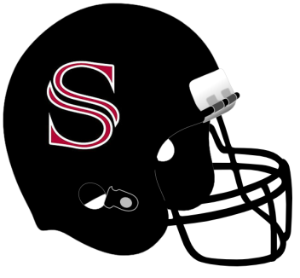
All orders must be turned in by August 8.
No late orders will be accepted.
Turn orders into Jennifer Ickes
Checks should be made payable to
Sparkman High School Football and MUST include a telephone number
2017 SHS Football Spirit Pack

VIP Game Day Package*  $100.00  (2) T-Shirts  (1) Program  (2) Reserved Seats  (does NOT include admission ticket or parking)  *5 Home Games | Small | Medium | Large | XL | 2X | 3X | Seat  Number (s) | Total Qty | Total $

Program Package  $20.00  (1) Program | Total Qty | Total $

T-Shirt Package  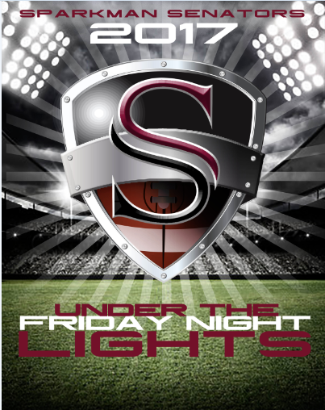  $15.00  (1) T-Shirt | Small | Medium | Large | XL | 2X | 3X | Total Qty | Total $
Reserved Seating Package*  $60.00  (2) Seats  (does NOT include admission ticket or parking)  *5 Varsity Home Games | Seat  Number (s) | Total Qty | Total $

Name:
Player Name:
Phone Number:
2017 SHS Football Spirit Pack

All orders must be turned in by August 8.
No late orders will be accepted.
Turn orders into Jennifer Ickes
Checks should be made payable to
Sparkman High School Football and MUST include a telephone number

